

**CINE CLICK- MOVIE BOOKING WEBSITE**



**DOCUMENTATION**

DONE BY:

**NIDHEESH PANCHAL 2016UCP1008**

**VANDITA GOYAL 2016UCP1004**

**AKSHITA AGRAWAL 2016UCP1023**

UNDER THE GUIDANCE OF: **DR NAMITA MITTAL**

**Contents**

1. **Introduction about the Project**
2. Introduction
3. Purpose
4. Scope of the Project
5. References
6. Overview
7. **Overall Description**
8. Project Functions
9. Constraints
10. Assumptions and Dependencies
11. **Specific Requirements**
12. **External Interfaces Requirements**

I. User Interfaces

II. Software Interfaces

III. Hardware Interfaces

IV. Communication Interfaces

**B. Performance Requirements**

**C. Security Requirements**

**D. Safety Requirements**

**E. Capacity Requirements**

**F. Availability Requirements**

**G. Software System Attributes**

1. **APPENDICES**
2. Normalization and ER Diagrams
3. Conclusion

**INTRODUCTION**

**Purpose**

CineClick is a movie-booking application made using MySql and Java-GUI. It allows a registered customer to check for the screenings of various movies in different cinema halls across different cities, book seats in said halls while also informing the customer of any clash of movie screenings that may occur on choosing a particular movie screening.

**Scope of Project**

CineClick relies on a user friendly and simple interface that users can adapt to easily. As a result, anyone with an Internet Connection, an email address and low level of experience with technology can use this system. As of now, CineClick is available only in certain cities and urban centers. Users should also hold a verified debit or credit card to make bookings.

**References**

1. Creately

2. Tutorials Point

3. Slide Share

4. Quora

5. Database Systems – Elmasri Navathe

**Overview**

The remaining sections of this documentations describes the overall descriptions which includes project perspective and functions, characteristics of users. It also consists of Assumptions, and Constraints. Overall description is listed in section 2. Section 3 includes Specific Requirements which consists of Functional and Non-functional requirements, External Interface Requirements, Software System Attributes, Performance Requirements, Capacity Requirements, Availability Requirements and Safety Requirements etc.

**OVERALL DESCRIPTION**

**Project Functions**

**Password protected accounts for users(with forgot password option)**

**Main page featuring currently running movies with genre and description.**

**Quick and user friendly booking(multiple bookings are also allowed)**

**Previous and upcoming bookings for a user**

**Easy cancellation up to 3 hours before a movie starts**

**Easy seat selection and secure payment(using dummy database)**

**A unique alert feature that informs the user if there is a clash in his/her movie bookings.**

**Email notifications regarding booking confirmation, refund status, clash in movie bookings etc.**

**Constraints**

1. **Memory:** System will have only 10GB space of data server.

2. **Language Requirement:** Project must be only in English.

3. **Budget Constraint:** Due to limited budget, CineClick is intended to be very simple and just to perform basic functionalities. UI is going to be user-friendly.

4. **Implementation Constraint:** Application should be based on DBMS and Java.

1. **Reliability Requirements:** System should sync frequently to backup server in order to avoid the data loss during failure, so it can be recovered.

**Assumptions and Dependencies**

It is assumed that system developed will work perfectly if all the listed requirements are met:

**SPECIFIC REQUIREMENTS**

**A. External Interfaces Requirements**

**1. User Interfaces**

The user interface for system shall be compatible with any type of web browser such as Mozilla Firefox, Google Chrome, and Internet Explorer.

**2. Software Interfaces**

* Database Server: MySQL
* Development End: Java GUI
* Tool for Databse: SQL Workbench
* Tool for Java GUI: NetBeans IDE 8.2

1. **Hardware Interfaces**

|  |  |  |  |
| --- | --- | --- | --- |
| **Server Side** | | | |
| **Monitor** | **Processor** | **RAM** | **Disk Space** |
| 1024x768 | Intel or AMD 2GHZ | 4GB | 10GB |
| **Client Side** | | | |
| **Monitor** | **Processor** | **RAM** | **Disk Space** |
| 1024x768 | Intel or AMD 1GHZ | 512MB | 2GB |

1. **Communication Interfaces**

The System shall be using **HTTP/HTTPS** for communication over Internet and for intranet communications, it shall use TCP/IP protocol.

**B. Performance Requirements**

**NF1.** Data in database should be updated within 2 seconds.

**NF2.** Query results must return results within 5 seconds.

**NF3.** Load time of UI should not take more than 2 seconds.

**NF4.** Login Validation should be done within 3 seconds.

**NF5.** Response to customer inquiry must be done within 5 minutes.

**C. Security Requirements**

**NF6.** All external communications between the data’s server and client must be encrypted.

**NF7.** All data must be stored, protected or protectively marked.

**NF8.** Payment Process should use HTTP over Secure protocol to secure the payment transactions.

**D. Safety Requirements**

**NF9.** Database should be backed up every hour.

**NF10.** Under failure, system should be able to come back at normal operation under an hour.

**E. Capacity Requirements**

**NF11.** Not more than 10,000 members to be registered.

**NF12.** System needs to handle at least 20 transactions during peak hours.

**F. Availability Requirements**

**NF13.** Report should be generated automatically every day for administrator and anytime upon request.

**G. Software System Attributes**

• **Correctness**: This system should satisfy the normal Educational site operations precisely to fulfil the end user objectives.

• **Efficiency:** Enough resources to be implemented to achieve the particular task efficiently without any hassle.

• **Flexibility**: System should be flexible enough to provide space to add new features and to handle them conveniently.

• **Integrity:** System should focus on securing the customer information and avoid data losses as much as possible.

• **Portability:** The system should run on any Windows environment.

• **Usability:** The system should provide user manual at every level.

• **Testability:** The system should be able to be tested to confirm the performance and clients specifications.

• **Maintainability:** The system should be maintainable.

**APPENDICES**

1. **Normalized schemas and ER Diagram:**

* **ER DIAGRAM OF CINECLICK:**

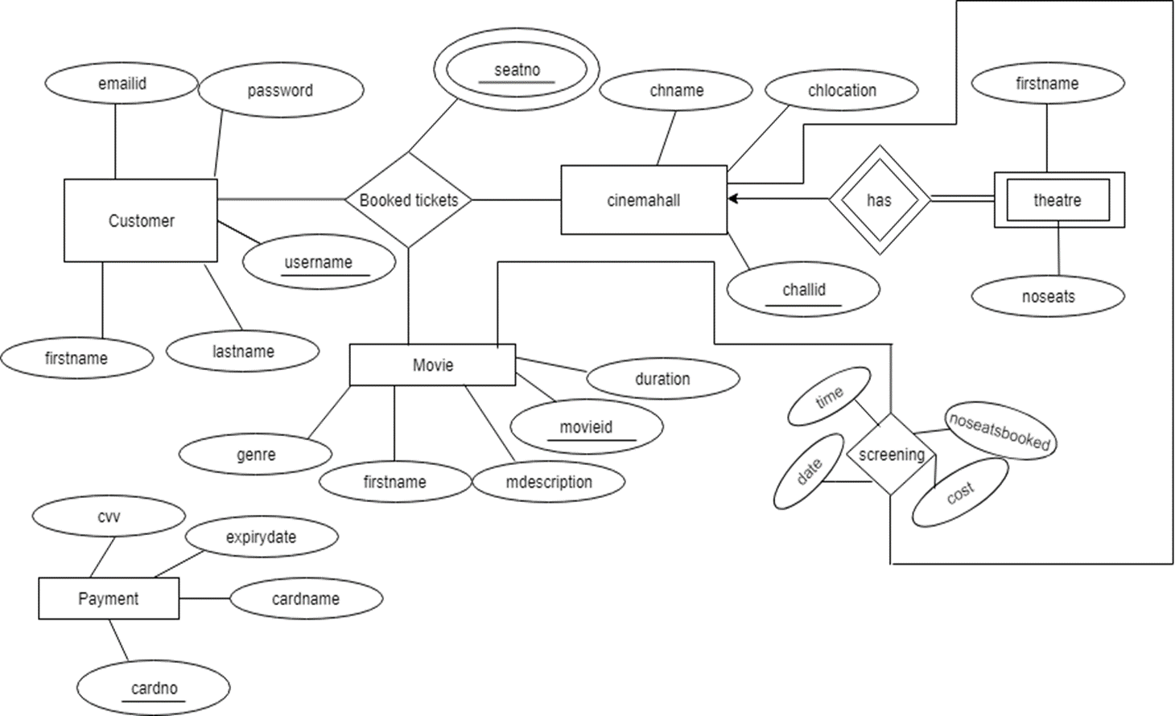

**NORMALIZED SCHEMAS**

**1. Customer (username,password,emailid,firstname,lastname)**

* **Primary key:** username
* **Super keys:** username,emailid
* Since, all values are atomic, this relation is in **1NF**
* Since there are no partial functional dependency, this relation is in **2NF**
* Since there are no transitive functional dependency, this relation is in **3NF**

**2. Cinemahall (challid,chname,chlocation)**

* **Primary key:** challid
* **Super keys:** challid
* Since, all values are atomic, this relation is in **1NF**
* Since there are no partial functional dependency, this relation is in **2NF**
* Since there are no transitive functional dependency, this relation is in **3NF**

**3. Theatre (theatreid,challid,noseats)**

* **Primary key:** (theatreid,challid)
* **Super keys:** (theatreid,challid)
* Since, all values are atomic, this relation is in **1NF**
* Since there are no partial functional dependency, this relation is in **2NF**
* Since there are no transitive functional dependency, this relation is in **3NF**
* **4. Movie (movieid,mname,mdescription,genre,duration)**
* **Primary key:** movieid
* **Super keys:** movieid, mname
* Since, all values are atomic, this relation is in **1NF**
* Since there are no partial functional dependency, this relation is in **2NF**
* Since there are no transitive functional dependency, this relation is in **3NF**

**5. Screening (movieid, theatreid,challid,time,date,noseatbooked,cost)**

* **Primary key:** (theatreid,challid,time,date)
* **Super keys:** (theatreid,challid,time,date),((theatreid,challid,time,date,movieid)...
* Since, all values are atomic, this relation is in **1NF**
* Since there are no partial functional dependency, this relation is in **2NF**
* Since there are no transitive functional dependency, this relation is in **3NF**

**6. Ticket (username, theatreid,challid,time,date,seatno)**

* **Primary key:** (theatreid, challid, time, date, seatno)
* **Super keys:** (theatreid, challid, time, date, seatno),(theatreid, challid, time, date, username)...
* Since, all values are atomic, this relation is in **1NF**
* Since there are no partial functional dependency, this relation is in **2NF**
* Since there are no transitive functional dependency, this relation is in **3NF**

**7. Payment (cardno, cvv, cardname, expirydate)**

* **Primary key:** cardno
* **Super keys:** cardno
* Since, all values are atomic, this relation is in **1NF**
* Since there are no partial functional dependency, this relation is in **2NF**
* Since there are no transitive functional dependency, this relation is in **3NF**

**B. Conclusion**

An application has been developed using mysql development and Java NetBeans so as to meet the requirements of a movie booking website, thereby ensuring quality performance.

The data can be accessed, manipulated and retrieved very easily. To conclude this project has proved to be a user-friendly interface.